**1.Question 1**

**What does a neuron compute?**

A neuron computes a linear function (z = Wx + b) followed by an activation function

Correct, we generally say that the output of a neuron is a = g(Wx + b) where g is the activation function (sigmoid, tanh, ReLU, ...).

**2.Question 2**

**Which of these is the "Logistic Loss"?**

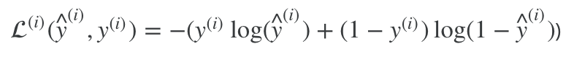

Correct, this is the logistic loss you've seen in lecture!

**3.Question 3**

**Suppose img is a (32,32,3) array, representing a 32x32 image with 3 color channels red, green and blue. How do you reshape this into a column vector?**

x = img.reshape((32*32*3, 1))

4.Question 4

**Consider the two following random arrays "a" and "b":**

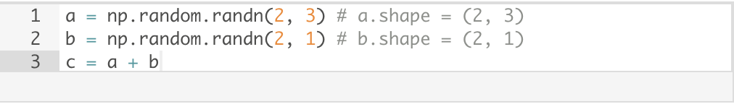

**What will be the shape of "c"?**

c.shape = (2, 3)

Yes! This is broadcasting. b (column vector) is copied 3 times so that it can be summed to each column of a.

5.Question 5

**Consider the two following random arrays "a" and "b":**

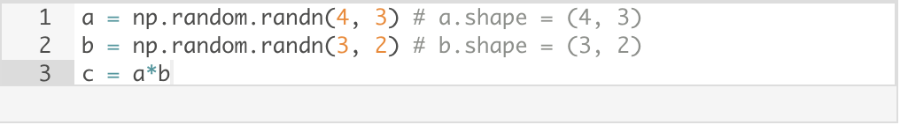

**What will be the shape of "c"?**

The computation cannot happen because the sizes don’t match. It’s going to be Error

Indeed! In numpy the "*" operator indicates element-wise multiplication. It is different from "np.dot()". If you would try "c = np.dot(a,b)" you would get c.shape = (4, 2).

<https://www.gautamkrishnar.com/an-intro-to-numpy/>

.Question 6

**Suppose you have n_x*nx*​ input features per example. Recall that X = [x^{(1)} x^{(2)} ... x^{(m)}]*X*=[*x*(1)*x*(2)...*x*(*m*)]. What is the dimension of X?**

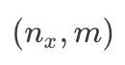

7.Question 7

**Recall that "np.dot(a,b)" performs a matrix multiplication on a and b, whereas "a*b" performs an element-wise multiplication.**

**Consider the two following random arrays "a" and "b":**

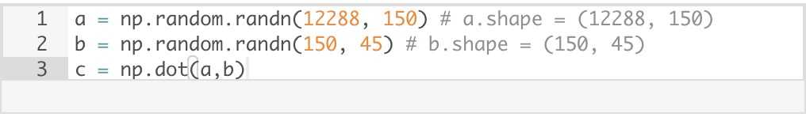

**What is the shape of c?**

c.shape = (12288, 45)

Correct, remember that a np.dot(a, b) has shape (number of rows of a, number of columns of b). The sizes match because :

"number of columns of a = 150 = number of rows of b"

**8.Question 8**

**Consider the following code snippet:**

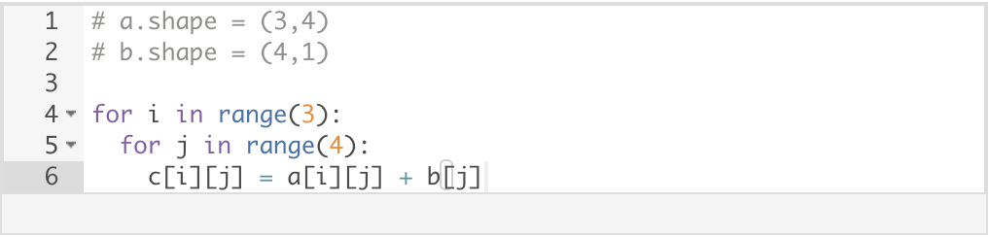

**How do you vectorize this?**

c = a + b.T

**9.Question 9**

**Consider the following code:**

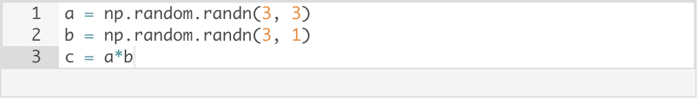

This will invoke broadcasting, so b is copied three times to become (3, 3), and * is an element-wise product so c.shape will be (3, 3)

**10.Question 10**

**Consider the following computation graph.**

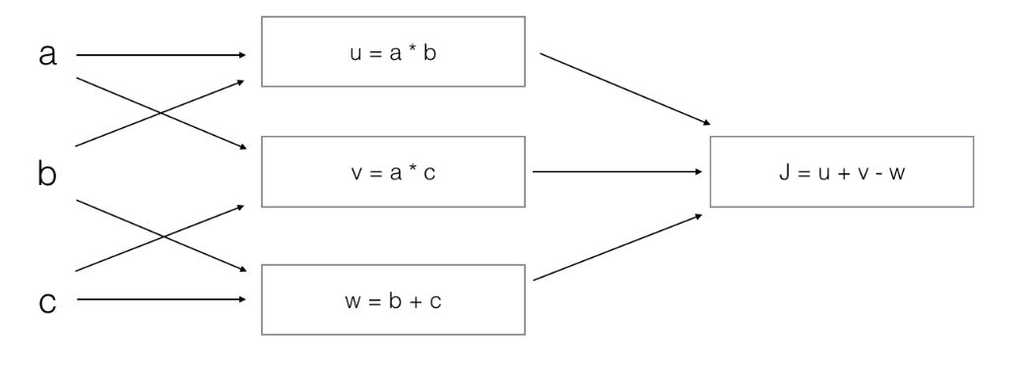

**What is the output J?**

J = (a - 1) * (b + c)

Yes. J = u + v - w = a*b + a*c - (b + c) = a * (b + c) - (b + c) = (a - 1) * (b + c).